Force and Pressure - 02
CLASS 08 - SCIENCE

 | Section A
1 | Read the text carefully and answer the questions: Student of class 8 playing tug of war in the playground. Suddenly the teacher came call all the student and start telling some facts related to the game. That the two teams pull the rope in opposite directions. Members of both the teams try to pull the rope in their direction. Sometimes the rope simply does not move. 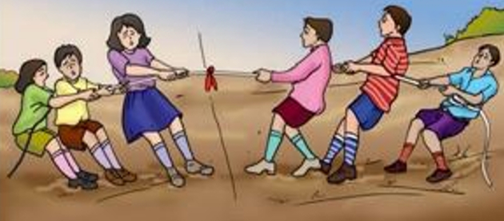  - When two forces act in opposite directions, then net force acting is the  - a) sum of two forces  - b) both some of two forces and difference between two forces  - c) difference between two forces  - d) none of these  - If two forces act in the opposite directions on an object, the net force acting on it is the  - a) difference between the two forces  - b) Multiplication of the two forces  - c) Division of the two forces  - d) Sum of the two forces  - A ________ exerted by an object on another is a force.  - a) Push or pull  - b) Pressure  - c) Magnitude  - d) Contact or non - contact force  - Forces applied on an object in the same direction subtract to one another.  - The strength of a force is usually expressed by its ________. | [5]
2 | Read the text carefully and answer the questions: Teacher of class 8 performed the following activity in the class. Step 1 - Take a plastic bottle. Fix a cylindrical glass tube, a few cm long near its bottom Step 2 - Cover the mouth of the glass with a thin rubber sheet. Step 3 - Now fill the bottle up to half with water. Step 4 - Some changes occur. Pour some more water in the bottle. 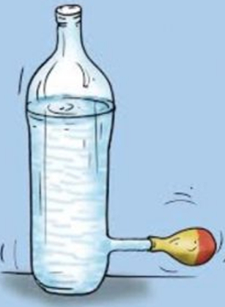  - The above activity demonstrates  - a) Weight exerts pressure  - b) Water exert pressure  - c) None of these  - d) Air exert pressure  - Pressure exerted by liquid decreases by  - a) Decrease width depth  - b) Increases with depth  - c) Is different in different direction at the same depth  - d) Doesn’t change with depth  - The rubber sheet has been fixed on the side of the container and not at the bottom indicate  - a) container does not exert pressure  - b) Container exert pressure on the side of wall  - c) Container exert pressure on the bottom  - d) None of these  - The force acting on a unit area of a surface is called  - Gases, too, exert pressure on the walls of their container. | [5]
3 | Read the text carefully and answer the questions: Step 1 - Take a ball and place it on a level surface. Step 2 - Make the ball move by giving it a push. Step 3 - Now place the ruler from your geometry box in its path. Step 4 - Does the ball continue to move in the same direction after it strikes the ruler Step 5 - In each case note your observations about the direction of motion of the ball after it strikes the ruler. 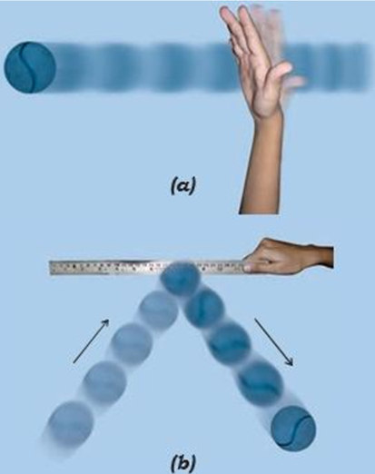  - The state of rest is considered to be the state of ________ speed.  - a) Three  - b) One  - c) Two  - d) Zero  - Force changes the  - a) motion of body  - b) all of these  - c) speed of body  - d) shape of body  - State of the motion is described by  - a) Both position of rest and position of motion  - b) position of rest  - c) None of these  - d) Position of motion  - If the force applied on the object is in the direction of its motion, the speed of the object ________.  - Force has magnitude as well as direction. | [5]
4 | Read the text carefully and answer the questions: There are 3 type of non - contact forces following activity describe one of them. Step 1 - Take a pair of bar magnets. Place the longer side of one of the magnets over three round shaped. Step 2 - Bring one end of the other magnet near the end of the magnet placed on the rollers. Step 3 - Make sure that the two magnets do not touch each other. Step 4 - Bring the other end of the magnet near the same end of the magnet placed on the rollers. 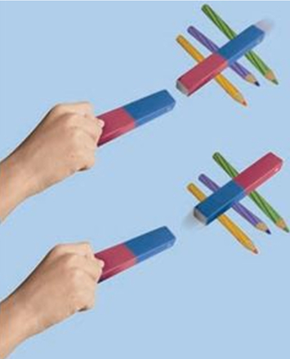  - The force describe in the above activity is.  - a) Gravitation force  - b) electrostatic force  - c) Magnetic force  - d) None of these  - The force that exerted by a charged body on another charged or uncharged body is known as  - a) Gravitation force  - b) electrostatic force  - c) None of these  - d) Magnetic force  - Objects or things fall towards the earth because it pulls them. This force is called  - a) force of gravity  - b) Force of magnetic  - c) All of these  - d) Force of electrostatic  - The force exerted by a magnet in the above activity is an example of a ________.  - In the above activity attraction or repulsion between objects can also beseen as another form of pull or push. | [5]
5 | Read the text carefully and answer the questions: Ankit is studying about contact forces. Firstly, he study about muscular force that it is the muscular force that enables us to perform all activities involving movement or bending of our body. All our body process is possible by muscular force. Muscular force of animal is used to carry out work. Secondly, he study about frictional force. 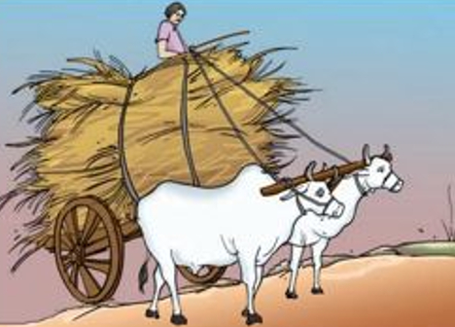  - The force of friction always acts on all the moving objects and its direction is always opposite to the direction of motion.  - a) downward  - b) upward  - c) Same side  - d) Opposite  - Which of the following is example of frictional force?  - a) All of these  - b) We stop paddlinga bicycle, it gradually slows down and finally comes to a stop.  - c) A car or a scooter also comes to rest once its engine is switched off.  - d) Boat comes to rest if we stop rowing it.  - The force exerted by our muscle is called  - a) electrostatic force  - b) gravitational force  - c) non - contact force  - d) muscular force  - When we push an object like a school bag or lift a bucket of water ________ force is applied.  - Animals also make use of muscular force to carry out their physical activities and other tasks. | [5]
 | Section B
6 | Force by the virtue of bodies in contact is called  a) strong force  b) weak force  c) contact force  d) non - contact force | [1]
7 | The fluid friction depends on  a) Shape of object  b) All of these  c) Speed of object with respect to fluid  d) Size of object | [1]
8 | A boy having area of 70 cm sq. exerts a pressure of 7N/cm sq. on the ground. The Force acting on the ground will be  a) 77 N  b) 10 N  c) 490 N  d) 100 N | [1]
9 | Two forces each of 20 N act simultaneously on a body, the maximum net force and minimum net force are  a) 40 N and 0  b) 20 N and 10 N  c) 20 N and 0  d) 40 N and 20 N | [1]
10 | Relation between the SI unit of force and the weight of a 1 kg mass is  a) 1 kgf = 1 N  b) 1 kgf = 9.8 N  c) 1 N = 9.8 kgf  d) 1 kgf = 0.98 N | [1]
11 | 1 horsepower is equal to -  a) 846 W  b) 746 W  c) 776 W  d) 11000 V | [1]
12 | S.I. unit of force is  a) Newton  b) Pascal  c) Watt  d) Joule | [1]
13 | The CGS unit of force is  a) Pascal  b) Dyne  c) Watt  d) Joule | [1]
14 | When batsman hits the ball, it changes its  a) Changes its direction only  b) Shape and size  c) Changes its speed only  d) Direction as well as speed | [1]
15 | A force of 200 N is applied to an object of area 2 sq. m. the pressure will be  a) 200 Pa  b) 400 Pa  c) 50 Pa  d) 100 Pa | [1]
16 | A body moving on leveled grounds need to apply constant force to  a) Contact force  b) Gravitational force  c) Overcome frictional force  d) Magnetic force of earth | [1]
17 | The force of gravitation acts  a) only between the earth and the bodies on it  b) only between the sun and the planets moving around it  c) between all bodies in the universe  d) only between the sun and the earth | [1]
18 | The value of g at the centre of earth becomes  a) Zero  b) 10 unit  c) $∞$ (infinite)  d) Unit (one) | [1]
19 | Which one is not the unit of pressure?  a) dyne cm$​^{−2}$  b) N - m$​^{−2}$  c) pascal  d) N - m$​^{−1}$ | [1]
20 | The frictional force exerted by fluids is also called  a) Slag  b) Smug  c) Rung  d) Drag | [1]
21 | The threaded tyres of cars, trucks, and bus  a) Increase the velocity of vehicles  b) Provide better grips with ground  c) Increase the diameter  d) Decrease friction of ground | [1]
22 | While walking on the ground we apply force on  a) friction  b) ground  c) gravitational  d) shoes | [1]
23 | A body will remain in state of motion on rolling on ground if  a) Friction is very large  b) Friction is absent  c) All of the above  d) Friction is acting on same direction | [1]
24 | A force applied on an object may change its  a) Colour  b) Mass  c) Weight  d) Speed | [1]
25 | Sometimes, car skids on rainy season  a) water reduces the friction between the road and the tyres  b) water increases the friction between the road and the tyres  c) it is not possible to apply brakes on a wet road  d) the friction between the brake shoes and the wheels is reduced | [1]
26 | One Newton is equal to  a) 1 g m/s$​^{2}$  b) 1 kg cm/s$​^{2}$  c) 1 kg m/s  d) 1 kg m/s$​^{2}$ | [1]
27 | During dry weather, while combing hair, sometimes we experience hair flying apart. The force responsible for this is  a) Force of friction  b) Electrostatic force  c) Force of gravity  d) Magnetic force | [1]
28 | The weight of air in a column of the height of the atmosphere and area 10cm$×$ 10 cm is equal to  a) 100 kg  b) 1000 kg  c) 58 kg  d) 9.8 kg | [1]
29 | The food can be cooked easily in pressure cooker, because -  a) Boiling happens at higher temprature  b) Pressure remains constant  c) Pressure change constantly  d) Boiling happens at lower temperature | [1]
30 | Pressure is -  - Scalar Quantity  - Vector Quantity  - BothScalar and Vector Quantity  - Tensor Quantity  a) option (iii)  b) option (ii)  c) option (i)  d) option (iv) | [1]
31 | A perpendicular force of 50 N is acting on a circular plate of radius 7cm. The pressure acting on plate will be  a) 10 Pa  b) 100 Pa  c) 1000 Pa  d) 3246.75 Pa | [1]
32 | Which one of the following forces is a contact force?  a) Magnetic force  b) Force of gravity  c) Electrostatic force  d) Force of friction | [1]
33 | A force of 5 N is applied on a body to create an acceleration of 2m/s. The mass of the body is equal to  a) 1.5 kg  b) 2 kg  c) 2.5kg  d) 5 kg | [1]
34 | The force required to overcome friction at the instant an object start moving from rest is measure of  a) Static friction  b) Sliding friction  c) Dragging friction  d) Rolling friction | [1]
35 | Pressure exerted by water at the bottom of the container depends on the  a) Size of the column  b) All of these  c) Mass of the column  d) Height of the column | [1]
36 | The soles of shoes are made up of groves to  a) it is very light  b) the earth attracts it  c) the air exerts a frictional force on it  d) increase friction force acts on it | [1]
37 | A metal cuboid of mass M kg rests on a table surface are of 40 cm$​^{2}$ in contact with the table. The pressure exerted by the cuboid on the table surface is 10000 Pa. Value of M is (given that g = 10 ms $​^{−2}$ )  a) 5 kg  b) 4 kg  c) 2.5 kg  d) 20 kg | [1]
38 | The bottom of dam is made thick due to  a) the water exerts low pressure on bottom wall  b) it is a custom  c) it looks beautiful  d) the water exerts more pressure on bottom wall | [1]
39 | Perpendicular force acting per unit area is called:  a) Energy  b) Thrust  c) Work  d) Power | [1]
40 | Why the food is cooked quickly in pressure cooker?  a) Steam cooks food quickly  b) Water boils at low temperature  c) Steam doesn’t go waste  d) Increased pressure, increases the boiling point | [1]
41 | Kicking a ball with our legs is an example of force of  a) gravitation  b) muscular  c) friction  d) magnetic | [1]
 | Section C
42 | A brick is kept in three different ways on a table as shown in Fig. The pressure exerted by the brick on the table will be 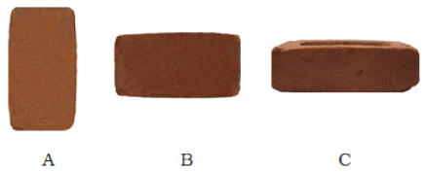  a) equal in all cases  b) maximum in position A  c) maximum in position C  d) maximum in position B | [1]
43 | A water tank has four taps fixed at points A, B, C, D as shown in Fig. The water will flow out at the same pressure from taps at 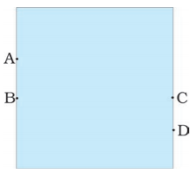  a) A and C  b) B and C  c) C and D  d) A and B | [1]
44 | In the circuit shown in Fig, when the circuit is completed, the hammer strikes the gong. Which of the following force is responsible for the movement of a hammer? 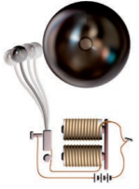  a) Magnetic force alone  b) Electrostatic force alone  c) Frictional force alone  d) Gravitational force alone | [1]
45 | In Fig. two boys A and B are shown applying force on a block. If the block moves towards the right, which one of the following statements is correct? 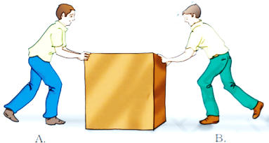  a) Magnitude of force applied by A is smaller than that of B.  b) Magnitude of force applied by A is greater than that of B.  c) Magnitude of force applied by A is equal to that of B.  d) Net force on the block is towards A. | [1]
46 | Fig. shows a container filled with water. Which of the following statements is correct about the pressure of water? 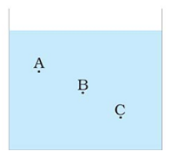  a) Pressure at A < Pressure at B <Pressure at C  b) Pressure at A < Pressure at B > Pressure at C  c) Pressure at A > Pressure at B > Pressure at C  d) Pressure at A = Pressure at B = Pressure at C | [1]
 | Section D
47 | Astronauts wear special suits when they go into space because pressure inside the suit is maintained at ______ .  a) Body pressure  b) Very low pressure  c) Atmospheric pressure  d) Variable pressure | [1]
48 | The pressure inside our bodies is __________ to the atmospheric pressure.  a) More  b) Equal  c) Less  d) Negligible | [1]
49 | To draw water from a well we have to ______ the rope.  a) Contract  b) Stretch  c) Pull  d) Push | [1]
50 | Friction opposes the __________ between two surfaces in contact.  a) Rotary motion  b) Relative motion  c) Refractive motion  d) Reflective motion | [1]
51 | The net force on an object is __________ if the two forces acting on it in opposite directions are equal.  a) Zero  b) Towards left  c) Always more  d) Towards right | [1]
52 | Force is a ______________ quantity.  a) Vector  b) Scalar  c) Repulsive  d) Attractive | [1]
53 | An interaction of one object with another object ________ between the two objects.  a) Results in a force  b) Results in a work  c) Results in a pressure  d) All of these | [1]
54 | The north pole of magnet __________ the north pole of another magnet.  a) Attracts  b) Repels  c) Push  d) Pull | [1]
 | Section E
55 | When we press the bulb of a dropper with its nozzle kept in water, air in the dropper is seen to escape in the form of bubbles. Once we release the pressure on the bulb, water gets filled in the dropper. The rise of water in the dropper is due to -  a) gravity of the earth  b) atmospheric pressure  c) shape of rubber bulb  d) pressure of water | [1]

